 | Department of Computer Science and Engineering  Faculty of Engineering, University of Moratuwa  CS 2033 – Data Communication and Networking  B. Sc. Engineering Semester 3
Student Name ……………………………………………………..…… Field: CSE
Index No ………………………………...……..

Lab 5 : IP Addressing

- How many octets are there in an IP address?

- How many bits per octet?

- List all the private IP address blocks.

- Determine the network and broadcast addresses, number of hosts for the given IPv4 addresses, and prefixes in the following table.:

Host IP address | Network address | Number of hosts | Broadcast address
192.168.100.25/28
172.30.10.130/30
10.1.113.75/19
172.16.104.99/27
128.107.14.191/22

- You are given an IP block of 10.10.10.0/24
  - subnet and allocate IP addresses to a laboratory with 30 computers and 2 offices with 5 computers each in an optimal way, and complete the following table
Location | Network address | Broadcast address | First usable address | Last usable address
Laboratory
Office A
Office B
  - Create a network as shown in the picture below, as shown laboratory computers and office computers are distributed among two floors. Each floor has a switch to connect computers. These switches are connected using ethernet interfaces.

Note: In the network engineering lab, there are 6 workstations, each equipped with three computers, and a switch. You can assume each workstation to be a floor (as mentioned in the diagram above) and take one computer each for Lab-pc, Office A and Office B. For this lab a single group requires two workstations. Thus, arrange into groups of 8 or 9 so that there will be three student groups at a time in the lab, each group having two workstations.

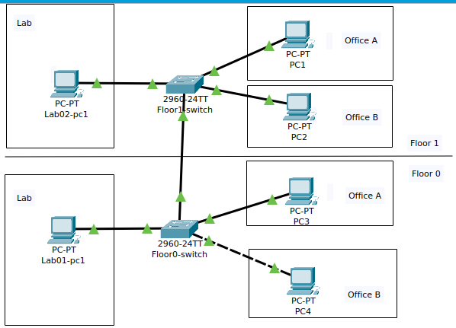

  - Assign IP addresses to each computer based on your IP address plan.
  - Ping to different computers as given in the table, write your observation, and state why you could/could not ping.
Computer from → to | Observation | Reason
Lab01-pc1 → Lab02-pc2
Lab01-pc1 →PC3
PC3 → PC1
PC3 → PC4

Note: Each of one of you should do an individual labsheet submission to moodle submission link.

